**Topics: Descriptive Statistics and Probability**

1. Look at the data given below. Plot the data, find the outliers and find out $μ, σ, σ^{2}$

|  |  |
| --- | --- |
| **Name of company** | **Measure X** |
| Allied Signal | 24.23% |
| Bankers Trust | 25.53% |
| General Mills | 25.41% |
| ITT Industries | 24.14% |
| J.P.Morgan & Co. | 29.62% |
| Lehman Brothers | 28.25% |
| Marriott | 25.81% |
| MCI | 24.39% |
| Merrill Lynch | 40.26% |
| Microsoft | 32.95% |
| Morgan Stanley | 91.36% |
| Sun Microsystems | 25.99% |
| Travelers | 39.42% |
| US Airways | 26.71% |
| Warner-Lambert | 35.00% |

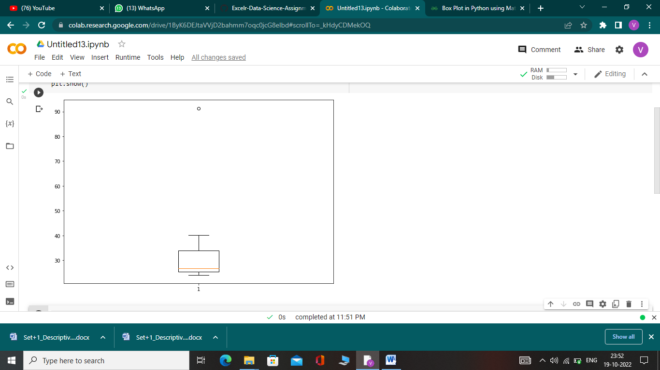

***µ* = 0.3327**

***σ* = 0.1694**

$σ^{2}=$**0.0287**

**Morgan Stanley is outlier having value of measure X = 91.36%.**



Answer the following three questions based on the box-plot above.

1. What is inter-quartile range of this dataset? (please approximate the numbers) In one line, explain what this value implies.

**Answer: IQR of this dataset is = 7**

**IQR (inter-quartile range) is range lies between 1st quartile and 3rd quartile. Most of the data of data set lies in this range.**

1. What can we say about the skewness of this dataset?

**Answer: This dataset is positively skewed.**

1. If it was found that the data point with the value 25 is actually 2.5, how would the new box-plot be affected?

**Answer: New box-plot will have many changes like Mean and median will change and it will also affect the IQR and there will be no outliers.**



Answer the following three questions based on the histogram above.

1. Where would the mode of this dataset lie?

**Answer: Mode of this dataset lie between Y= 4 to Y= 8**

1. Comment on the skewness of the dataset.

**Answer: This dataset is positively skewed.**

1. Suppose that the above histogram and the box-plot in question 2 are plotted for the same dataset. Explain how these graphs complement each other in providing information about any dataset.

**Answer: Its easy to identify outlier in both histogram and boxplot.**

1. AT&T was running commercials in 1990 aimed at luring back customers who had switched to one of the other long-distance phone service providers. One such commercial shows a businessman trying to reach Phoenix and mistakenly getting Fiji, where a half-naked native on a beach responds incomprehensibly in Polynesian. When asked about this advertisement, AT&T admitted that the portrayed incident did not actually take place but added that this was an enactment of something that “could happen.” Suppose that one in 200 long-distance telephone calls is misdirected. What is the probability that at least one in five attempted telephone calls reaches the wrong number? (Assume independence of attempts.)

**Answer: Let P= Probability of call misdirected**

**P= $\frac{1}{200}$**

**P2 = Probability of call is correct**

**P2= $\frac{199}{200}$ = 0.967**

**Probability that at least one in five attempts telephone calls misdirected= 1-(0.967)ᶺ5=0.0247**

**There is 2% chance.**

1. Returns on a certain business venture, to the nearest $1,000, are known to follow the following probability distribution

|  |  |
| --- | --- |
| x | P(x) |
| -2,000 | 0.1 |
| -1,000 | 0.1 |
| 0 | 0.2 |
| 1000 | 0.2 |
| 2000 | 0.3 |
| 3000 | 0.1 |

1. What is the most likely monetary outcome of the business venture?

**Answer: $2000**

1. Is the venture likely to be successful? Explain

**Answer: Yes , because it has more probability of profits.**

**P(x) of loss=0.1+0.1= 0.2 & P(x) of profits= 0.2+0.3+0.1= 0.6**

1. What is the long-term average earning of business ventures of this kind? Explain

**Answer: The long term average earning of business ventures of this kind will be**

**= (3000*0.1)+(2000*0.3)+(1000*0.2)-(1000*0.1)-(2000*0.1)= 800**

1. What is the good measure of the risk involved in a venture of this kind? Compute this measure

**Answer: The good measure of risk involved in a venture of this kind is variance and standard deviation.**

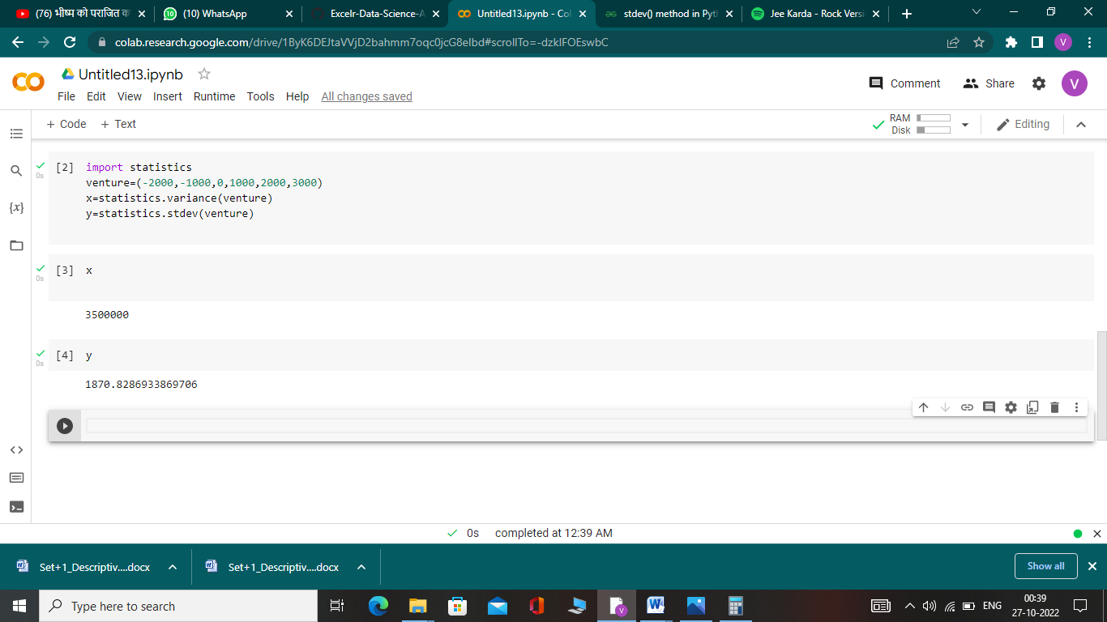

**Value of standard deviation is higher than average return value which implies that it is highly risky.**